Smart Pest Repeller

Andrew Albritton

Michael McNeil

Melquisedec Ordonez

**Functional System Requirements**

REVISION – Draft

25 September 2023

11

10

9

8

7

6

5

4

3

2

1

1

2

3

4

5

6

7

8

9

10

Summary

Outline

Introduction

Purpose and Scope

Responsibility and Change Authority

Applicable and Reference Documents

Applicable Documents

YOLOv5 GitHub

Reference Documents

Smart Ultrasonic Insects & Pests Repeller for Farms & Inventories Purpose

Humidity management of outdoor electronic equipment: methods, pitfalls, and recommendations

Order of Precedence

Requirements

System Definition

Characteristics

Functional / Performance Requirements

Variable Pest Responses

Search Probability of Detection

Image Classification Distance

Physical Characteristics

Volume Envelope

Mounting

Electrical Characteristics

Inputs

Power Consumption

Input Voltage Level

Outputs

Data Output

Diagnostic Output

Wiring

Environmental Requirements

Thermal

Rain

Humidity

Failure Propagation

Failure Detection, Isolation, and Recovery (FDIR)

Built In Test (BIT)

3.2.5.1.2 BIT False Alarms

Appendix A: Acronyms and Abbreviations

Appendix B: Definition of Terms

Functional System Requirements

for

Smart Pest Repeller

Prepared by:

_____________________________

Author Date

Approved by:

_____________________________

Project Leader Date

_____________________________

John Lusher, P.E. Date

_____________________________

T/A Date

**Change Record**

| **Rev.** | **Date** | **Originator** | **Approvals** | **Description** |
| --- | --- | --- | --- | --- |
| **0** | 9/25/23 | ALL |  | Draft Release |

**Table of Contents**

**Table of Contents** **26**

**List of Tables** **27**

**List of Figures** **28**

**1.** **Introduction 29**

1.1. Purpose and Scope **29**

1.2. Responsibility and Change Authority **29**

**2.** **Applicable and Reference Documents 30**

2.1. Applicable Documents **30**

2.2. Reference Documents **30**

2.3. Order of Precedence **31**

**3.** **Requirements 32**

3.1. System Definition **32**

3.2. Characteristics **33**

3.2.1. Functional / Performance Requirements **33**

3.2.1.1. Variable Pest Responses **33**

3.2.1.2. Search Probability of Detection **33**

3.2.1.3. Image Classification Distance **33**

3.2.2. Physical Characteristics **34**

3.2.2.1. Volume Envelope **34**

3.2.2.2. Mounting **34**

3.2.3. Electrical Characteristics **35**

3.2.3.1. Inputs **35**

3.2.3.1.1. Power Consumption **35**

3.2.3.1.2. Input Voltage Level **35**

3.2.3.2. Outputs **36**

3.2.3.2.1. Data Output **36**

3.2.3.2.2. Diagnostic Output **36**

3.2.3.3. Wiring **36**

3.2.4. Environmental Requirements **37**

3.2.4.1. Thermal **37**

3.2.4.2. Rain **37**

3.2.4.3. Humidity **37**

3.2.5. Failure Propagation **38**

3.2.5.1. Failure, Detection, Isolation, and Recovery **38**

3.2.5.1.1. Built In Test (BIT) **38**

3.2.5.1.2. BIT False Alarms **38**

**Appendix A Acronyms and Abbreviations** **39**

**Appendix B Definition of Terms** **40**

**Schedule 43**

**Validation Plan 44**

**List of Tables**

**Table 1. Subsystem Assignments 7**

**List of Figures**

**Figure 1. Project Conceptual Image 1**

**Figure 2. Block Diagram of System 4**

# Introduction

## Purpose and Scope

The purpose of this document is to describe the system requirements for our assigned project. Our assigned project’s purpose is to provide an alternative solution for high frequency based pest control. Current pest control models only target one subset of organisms (IE: rodents, flies, or larger mammals), our device shall be able to target a range of organisms including: flies, rodents, and lizards. The system shall output a specific frequency corresponding with the found organism. This frequency will cause organisms to vacate the effective area of the transmitter.

Figure 1 shows a conceptual finished product as proposed in the CONOPS report.

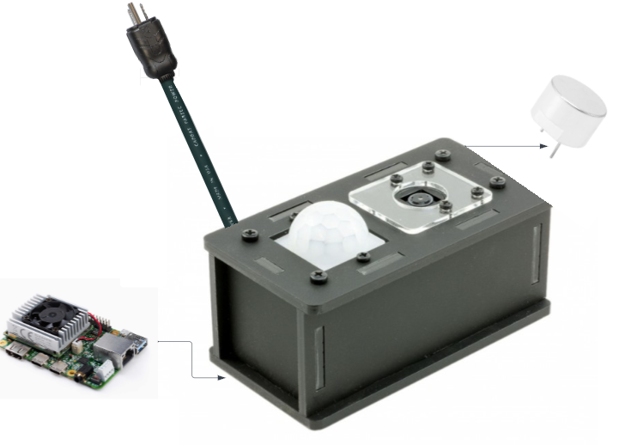

**Figure 1. Project Conceptual Image**

## Responsibility and Change Authority

The team leader, Melquisedec Ordonez, will be responsible for ensuring that all requirements are met. These requirements can be changed with the approval of the team leader and sponsor Peng Hao Huang.

| **Subsystem** | **Assigned Member** |
| --- | --- |
| Power Supply and Battery System | Michael McNeil |
| Machine Learning Algorithm, Motion Sensor, and Camera Interface | Andrew Albritton |
| Signal Generation and Transmission | Melquisedec Ordonez |

*Table 1: Subsystem Assignments*

# Applicable and Reference Documents

## Applicable Documents

The following documents, of the exact issue and revision shown, form a part of this specification to the extent specified herein:

| **Document Number** | **Revision/Release Date** | **Document Title** |
| --- | --- | --- |
| [ultralytics/yolov5: YOLOv5 🚀 in PyTorch > ONNX > CoreML > TFLite (github.com)](https://github.com/ultralytics/yolov5/tree/master) | 22 November 2022 | YOLOv5 GitHub |
| 978-1-5090-0917-6 | 16-19th October 2016 | An Overview of the Fundamentals of Battery Chargers |
| G950-01455-01 | December 2022 | Coral Dev Board Datasheet |

## Reference Documents

The following documents are reference documents utilized in the development of this specification. These documents do not form a part of this specification and are not controlled by their reference herein.

| **Document Number** | **Revision/Release Date** | **Document Title** |
| --- | --- | --- |
| 978-1-5386-5368-5 | 28-29th December 2018 | Smart Ultrasonic Insects & Pests Repeller for Farms & Inventories Purpose |
| 1910.305 | 16 January 1981 | Wiring methods, components, and equipment for general use. |
| 1521-3331 | March 2002 | Humidity management of outdoor electronic equipment: methods, pitfalls, and recommendations |

## Order of Precedence

In the event of a conflict between the text of this specification and an applicable document cited herein, the text of this specification takes precedence without any exceptions.

All specifications, standards, exhibits, drawings or other documents that are invoked as “applicable” in this specification are incorporated as cited. All documents that are referred to within an applicable report are considered to be for guidance and information only, except ICDs that have their relevant documents considered to be incorporated as cited.

# Requirements

*This section defines the minimum requirements that the development item(s) must meet. The requirements and constraints that apply to performance, design, interoperability, reliability, etc., of the system, are covered.*

## System Definition

The Smart Pest Repeller will run from power supplied via a battery or wall power. While in operation it will be monitoring for any possible pest activity. Once a pest is detected the ML algorithm will process the image and see if the organism present falls into one of the preset categories created for the program. If the organism is identified as belonging to one of those groups, then the emitter will output the corresponding frequency of sound until the system no longer detects the pest.

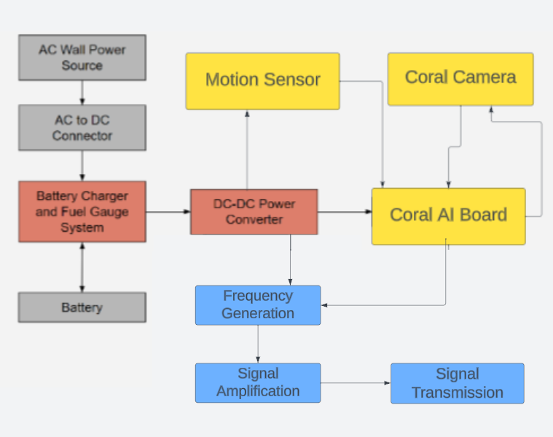

**Figure 2. Block Diagram of System**

*Describe the block diagram, what are the subsystems, how do they interconnect. Someone reading this section should get a general idea of what you are building, why, and how it will solve the problem you are solving.*

The power supply and battery system will ensure that the pest repeller system will be able to work while connected to a wall power source or on its own. While connected to the wall power source the system will use the wall power as the main source of power while charging the batteries via the battery charger circuit. The charging circuit will monitor the battery as it charges, ensuring that the battery does not over charge and potentially suffer damage. While the system receives power from the battery source the fuel gauge will monitor the batteries fuel levels. Once the battery fuel level reaches a point where the system needs to charge again soon, the system will have a light indicator to tell the user that the system needs to charge. The power system will also incorporate a DC to DC converter in order to ensure the voltage being sent to the microcontroller is consistent and usable at around 5 volts and 2 amps of output. Once motion is detected the photo taken by our Coral AI camera will be sent to the Coral AI dev board for image processing. This processing shall be done using an image recognition ML model.

The transmitter shall emit frequencies of: 38-44 kHz, 52-60 kHz, and 60-72 kHz. The emitter will receive its signal from a direct digital synthesizer(DDS). It will generate the unique signal for the pest in question and deliver it to the emitter for transmission. The signal is then amplified as needed for the emitter. Only one emitter and therefore one frequency will be used at a time. For multiple pests in the frame of the camera the repeller will target one pest until it is out of frame. The emitter will then emit a new frequency for the remaining pest(s) until all pests are out of frame of the camera.

## Characteristics

### Functional / Performance Requirements

#### Signal Emission Amplification

The system will amplify the emitter's three required ranges of frequencies at a minimum of 7V/V.

*Rationale: Signal coming from the emitter will be low and will need to be amplified to reach a wider distance.*

#### Search Probability of Detection

The Smart Pest Repeller classification subsystem shall have a probability of 90% of detection.

*Rationale: Most image classification algorithms settle to 85-93% after extensive training, so our goal will be to reach a slightly above average detection rate.*

#### Image Classification Distance

The Smart Pest Repeller shall have a classification distance of a maximum of 8ft for rodents / large lizards. Classification distance for small organisms may vary depending on given size (ie: fruit flies <2ft). Minimum distance of classification for larger organisms shall be 2ft.

*Rationale: The image classification model being used will have a larger chance of guessing the correct species, when said organism takes up greater space on camera. Organisms can also be too close, taking up too much space in the image, preventing classification.*

### Physical Characteristics

This is the area where you will specify any requirements regarding the physical characteristics of your system. Does the system need to not have a mass/weight higher than X, etc.? There are examples shown below…

#### Volume Envelope

The system shall have a maximum size of 6x6x14in, or the size of a shoe box. This box shall have openings allowing for image and motion sensing, as shown in figure 1. The mass of the system shall not exceed 10kg.

*Rationale: The size and mass will allow for deployment of the system to take place by hand.*

#### Mounting

The mounting height of the Smart Pest Repeller will be at a height of 2 ½ ft from the ground.

*Rationale: This will ensure proper image quality for processing and reduce possible classification errors.*

### Electrical Characteristics

#### Inputs

1. The presence or absence of any combination of the input signals in accordance with ICD specifications applied in any sequence shall not damage the Smart Pest Repeller, reduce its life expectancy, or cause any malfunction, either when the unit is powered or when it is not.
2. No sequence of command shall damage the Smart Pest Repeller, reduce its life expectancy, or cause any malfunction.
3. Motion sensor input shall be utilized to trigger the device’s camera to take a photo.

*Rationale: By design, should limit the chance of damage or malfunction by user/technician error. Also, motion detection should limit the need for constant data processing, saving power usage.*

##### Power Consumption

The maximum peak power of the system shall not exceed 15 watts.

*Rationale: This is a requirement in order to achieve the desired battery life outlined by the sponsor*

##### Input Voltage Level

The input voltage to the entire system will be a 120 Volt AC signal from a wall outlet.

*Rationale: This allows the system to work via wall power*

*.*

#### Outputs

##### Data Output

The smart pest repeller shall output frequencies corresponding with the output of the Coral AI board. The Coral AI board shall output three different control signals to trigger the speaker system.

*Rationale: The smart pest repeller must output the corresponding frequency to the found pest in order to have effective pest control.*

##### Diagnostic Output

The Smart Pest Repeller shall have an led marking when the battery needs to be charged.

*Rationale: Provides the ability to know when the device will need to utilize wall power.*

*.*

#### Wiring

The Smart Pest Repeller shall follow guidelines provided in document 1910.305 for wiring standards.

*Rationale: Conform to equipment for general use standard of OSHA guidelines*

### Environmental Requirements

The Smart Pest Repeller System shall be designed to withstand and operate in the environments and laboratory tests specified in the following section.

*Rationale: The device must be able to function consistently outdoors.*

#### Thermal

The smart pest repeller shall be able to function in a temperature range of 0℃-40℃

*Rationale: Average outdoor temperature within the United States falls within the range shown above.*

#### Rain

The Smart Pest Repeller shall function in light rain, while it is suggested that the device be taken inside during flooding.

*Rationale: The device should function in light rain but if there is a risk of the power cord being submerged in water or having contact with water, the device should be brought inside to prevent unwanted shorts.*

#### Humidity

We will be adhering to the IEEE standard for humidity and outdoors circuits in document 1521-3331.

### Failure Propagation

The Smart Pest Repeller shall not activate its high frequency transmitters on false activation of motion sensor.

#### Failure Detection, Isolation, and Recovery (FDIR)

##### Built In Test (BIT)

The Smart Pest Repeller image recognition shall have a label marked ignore when the three labels provided (fly, rodent, or lizard) have a low confidence margin or are not triggered. This test will be run three times to ensure detection before triggering an output.

*Rational: This test will assist in lowering false triggers of the device when nothing is present, or when a person/dog triggers the motion sensor*

###### 3.2.5.1.2 BIT False Alarms

False alarm rate shall be no more than 10%.

*Rationale: Error of the model will be around 10%, but checking over three different iterations will allow for results to be averaged and compared, allowing for mitigated false alarms below 10%.*

# 

# Appendix A: Acronyms and Abbreviations

AC Alternating Current

DDS Direct Digital Synthesizer

DC Direct Current

GPIO General Purpose In-Out port

Hz Hertz

MCU Microcontroller unit

ML Machine Learning

MLA Machine Learning Algorithm

BIT Built-In Test

ICD Interface Control Document

kHz Kilohertz (1,000 Hz)

LED Light-emitting Diode

mA Milliamps

mW Milliwatts

PCB Printed Circuit Board

TBD To Be Determined

# Appendix B: Definition of Terms

DC-DC converter: A circuit or device capable of sending a current from one voltage level to another, higher or lower than the original, input, signal.

Direct Digital Synthesizer: A device capable of producing a digital signal, typically sinusoidal, and converting it into an analog one.

(Ultrasonic) Emitter: A device, typically based on crystals and using the piezoelectric effect, that is able to take an electrical signal and convert it into an audio signal; can be an ultrasound signal as well.

Image Processing: The process of converting a digital image and separating it into bits of useful information that aids in a larger process, eg. recognizing certain traffic signals for autonomous driving vehicles.

.

Machine Learning: The use of computers to perform specific tasks without explicit instructions from a user. Instead the computer is given a set of models and statistical tools that it uses to extract and analyze data to perform desired action(s) on its own.

Microcontroller: a, typically small, integrated circuit that is able to control a certain set(s) of operation(s). Unlike a full personal computer a microcontroller is not required to run on an operating system.